Name:Roshini B T
Reg No:192524064
Course Code:ITA0613
EXPERIMENT NO: 1
FIND-S ALGORITHM
Aim
To implement and demonstrate the FIND-S algorithm for finding the most specific hypothesis that is consistent with a given set of positive training examples.
Procedure
- Collect a training dataset containing attributes and their corresponding target class labels.
- Initialize the hypothesis with the most specific values.
- Read each training example one by one.
- If the training example is positive (Yes):
  - Compare it with the current hypothesis.
  - If an attribute value differs, replace that attribute in the hypothesis with '?' (any value).
- Ignore all negative (No) training examples.
- Continue the process until all training examples are examined.
- Display the final hypothesis obtained.
- Verify that the final hypothesis correctly represents the most specific concept consistent with all positive examples.
INPUT:
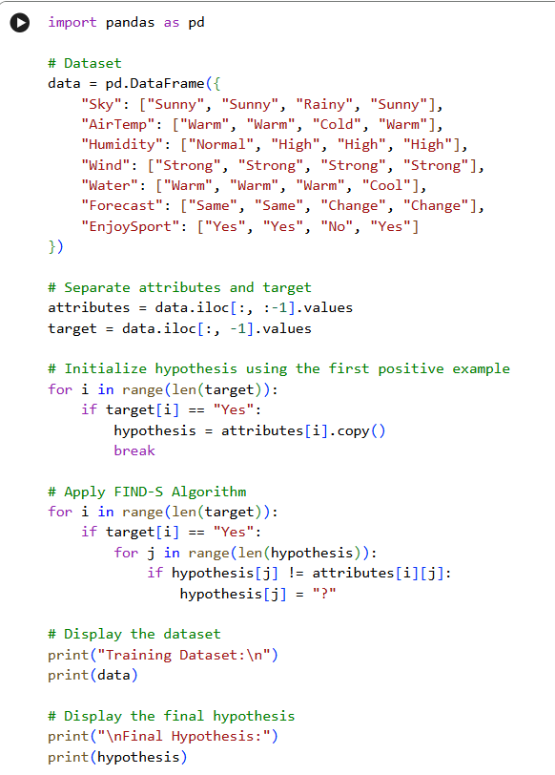

OUTPUT:
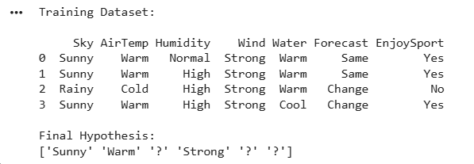

EXPERIMENT NO: 2
CANDIDATE-ELIMINATION ALGORITHM
Aim
To implement the Candidate-Elimination algorithm in Python to determine the version space by identifying all hypotheses that are consistent with the given training data stored in a CSV file.
Procedure
- Import the required Python libraries.
- Load the training dataset from a CSV file.
- Separate the attributes and target class labels from the dataset.
- Initialize the Specific Hypothesis (S) with the first positive training example.
- Initialize the General Hypothesis (G) with the most general hypothesis.
- Process each training example one by one.
- For each positive example, generalize the Specific Hypothesis (S) and remove inconsistent hypotheses from the General Hypothesis (G).
- For each negative example, specialize the General Hypothesis (G) by removing hypotheses that incorrectly classify the negative example while keeping them consistent with the Specific Hypothesis (S).
- Continue updating S and G until all training examples have been processed.
- Display the final Specific Hypothesis, General Hypothesis, and the Version Space containing all hypotheses consistent with the training data.
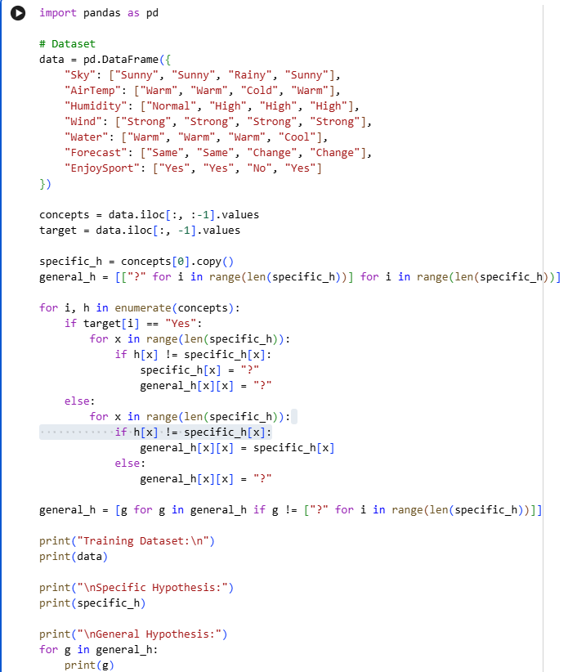
INPUT:

OUTPUT:
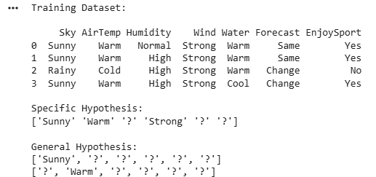

EXPERIMENT NO: 3
IMPLEMENTATION OF ID3 DECISION TREE ALGORITHM
Aim
To implement the ID3 Decision Tree algorithm in Python for building a decision tree model and to classify new data samples using the trained model.
Procedure
- Import the required Python libraries.
- Load the dataset from a CSV file.
- Preprocess the dataset by separating the input features and target labels.
- Calculate the entropy and information gain for each attribute.
- Select the attribute with the highest information gain as the root node.
- Recursively split the dataset to construct the decision tree.
- Train the ID3 Decision Tree model using the training dataset.
- Test the model with a new sample.
- Display the generated decision tree and the predicted class label.
- Evaluate the performance of the model using the test data.
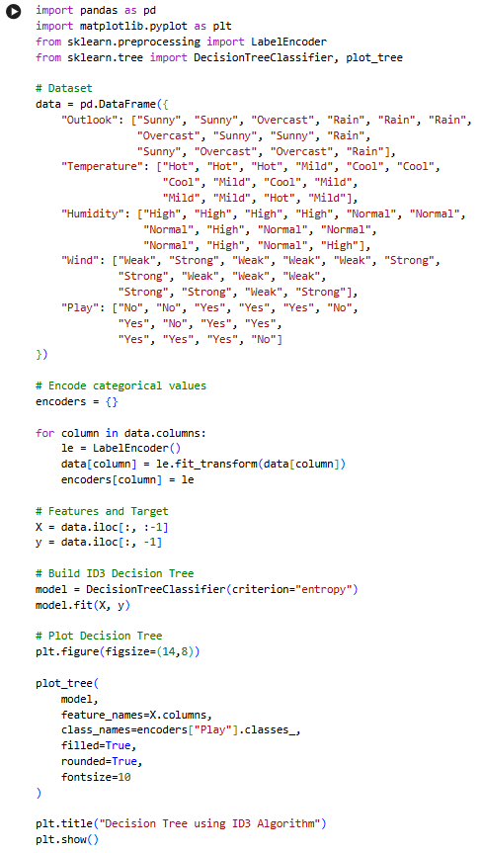
INPUT:

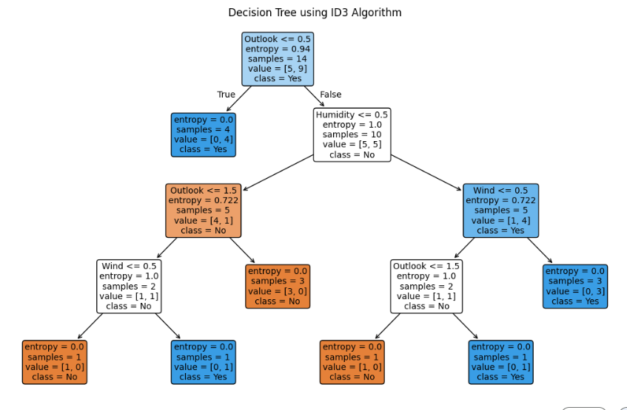
OUTPUT:

EXPERIMENT NO: 4
IMPLEMENTATION OF ARTIFICIAL NEURAL NETWORK USING BACKPROPAGATION ALGORITHM
Aim
To implement an Artificial Neural Network (ANN) using the Backpropagation algorithm in Python and test its performance using an appropriate dataset.
Procedure
- Import the required Python libraries.
- Load the dataset and preprocess the input features and target values.
- Split the dataset into training and testing sets.
- Initialize the Artificial Neural Network with input, hidden, and output layers.
- Assign random weights and biases to the network.
- Train the network using the Backpropagation algorithm by performing forward and backward propagation.
- Update the weights iteratively to minimize the error.
- Test the trained model using the testing dataset.
- Predict the output for the test samples.
- Display the predicted results and evaluate the performance of the neural network.
INPUT:
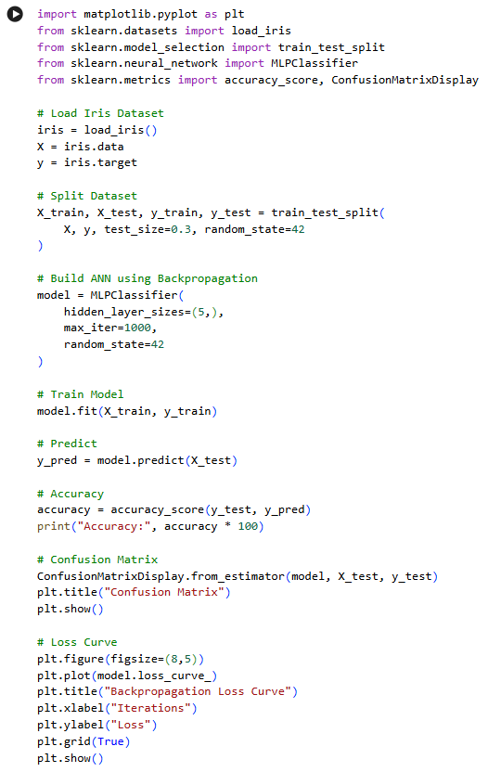

OUTPUT: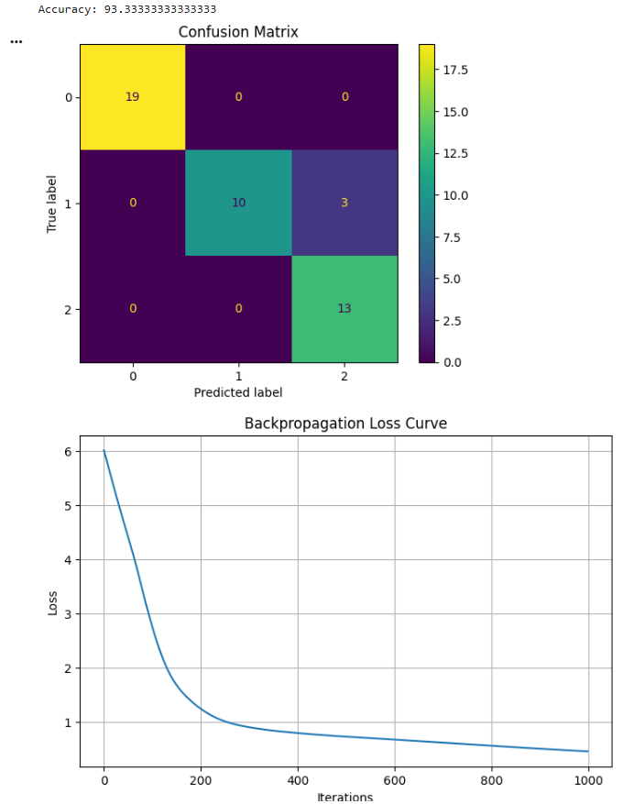

EXPERIMENT NO: 5
IMPLEMENTATION OF K-NEAREST NEIGHBOURS (K-NN) ALGORITHM
Aim
To implement the K-Nearest Neighbours (K-NN) algorithm in Python and classify the given data samples based on the nearest neighbours.
Procedure
- Import the required Python libraries.
- Load the dataset and preprocess the data.
- Split the dataset into training and testing sets.
- Select an appropriate value for K (number of nearest neighbours).
- Train the K-NN classifier using the training dataset.
- Calculate the distance between the test sample and all training samples.
- Identify the K nearest neighbours based on the calculated distances.
- Predict the class label using the majority voting method.
- Display the predicted results for the test dataset.
- Evaluate the performance of the K-NN model using suitable evaluation metrics such as accuracy.
INPUT
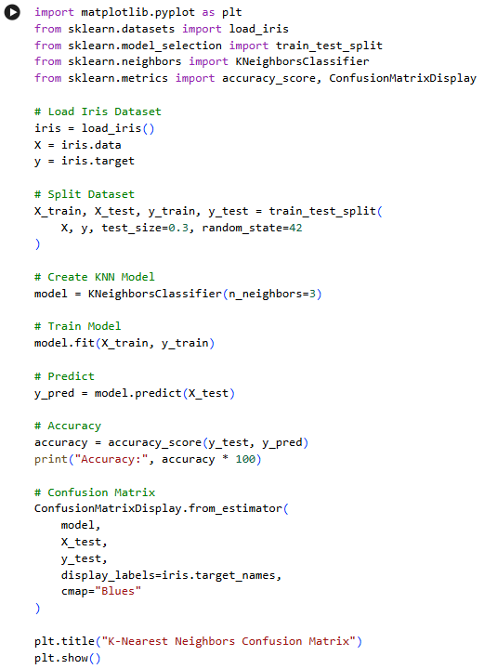

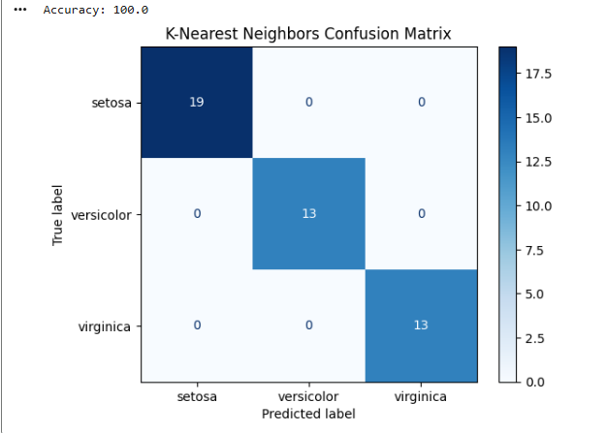
OUTPUT

EXPERIMENT NO: 6
IMPLEMENTATION OF NAÏVE BAYES ALGORITHM
Aim
To implement the Naïve Bayes algorithm in Python and evaluate its performance using a confusion matrix and accuracy score.
Procedure
- Import the required Python libraries.
- Load the dataset and preprocess the data.
- Split the dataset into training and testing sets.
- Train the Naïve Bayes classifier using the training dataset.
- Use the trained model to predict the class labels for the test dataset.
- Compare the predicted labels with the actual labels.
- Generate the confusion matrix to evaluate the classification results.
- Calculate the accuracy of the model.
- Display the confusion matrix and accuracy score.
- Interpret the results obtained from the Naïve Bayes classifier
INPUT
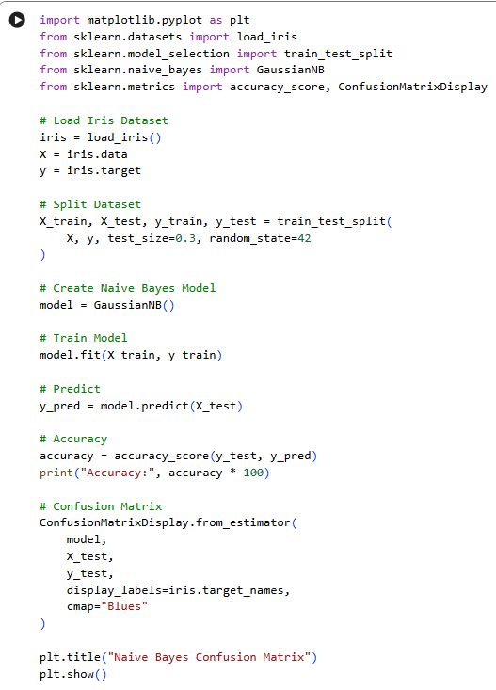

OUTPUT
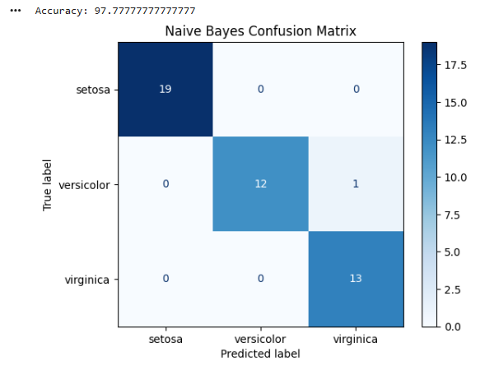

EXPERIMENT NO: 7
IMPLEMENTATION OF LOGISTIC REGRESSION ALGORITHM
Aim
To implement the Logistic Regression algorithm in Python for classifying data and predicting the target class using an appropriate dataset.
Procedure
- Import the required Python libraries.
- Load the dataset and preprocess the data.
- Split the dataset into training and testing sets.
- Create and train the Logistic Regression model using the training dataset.
- Predict the class labels for the testing dataset.
- Compare the predicted labels with the actual labels.
- Evaluate the model using suitable performance metrics such as accuracy.
- Display the predicted results.
- Analyze the performance of the Logistic Regression model.
- Interpret the classification results.
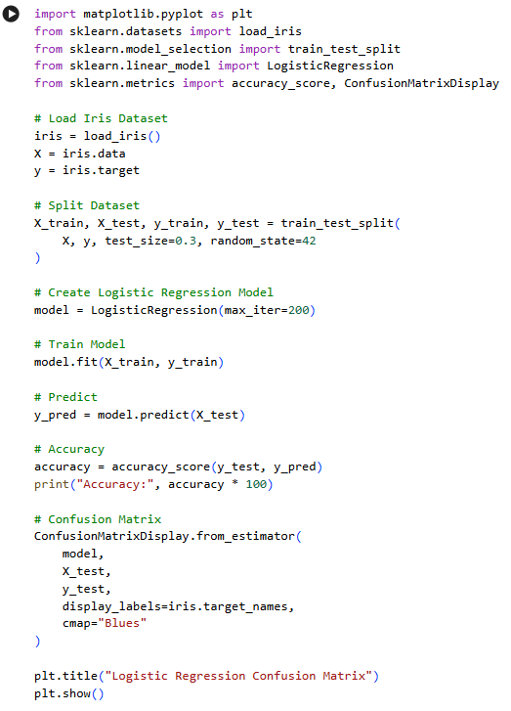
INPUT

OUTPUT
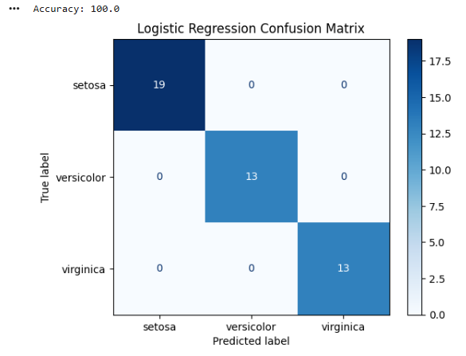

EXPERIMENT NO: 8
IMPLEMENTATION OF LINEAR REGRESSION ALGORITHM
Aim
To implement the Linear Regression algorithm in Python for predicting continuous values using an appropriate dataset.
Procedure
- Import the required Python libraries.
- Load the dataset and preprocess the data.
- Separate the input features and target variable.
- Split the dataset into training and testing sets.
- Create and train the Linear Regression model using the training data.
- Predict the target values for the testing dataset.
- Compare the predicted values with the actual values.
- Evaluate the performance of the model using suitable metrics such as Mean Squared Error (MSE) and R² score.
- Display the predicted results.
- Interpret the performance of the Linear Regression model.
INPUT
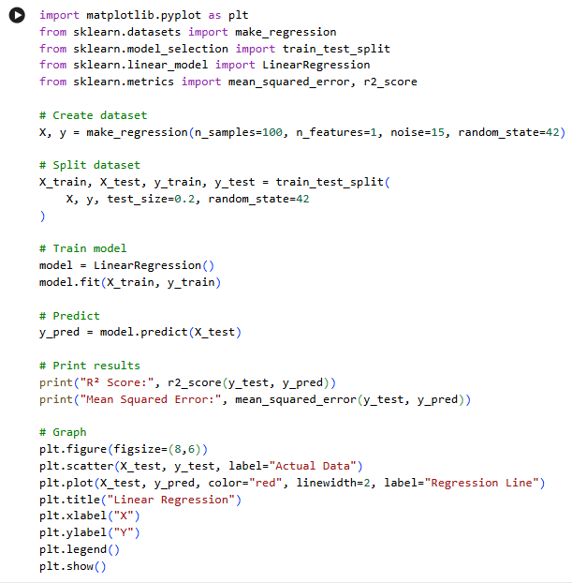

OUTPUT
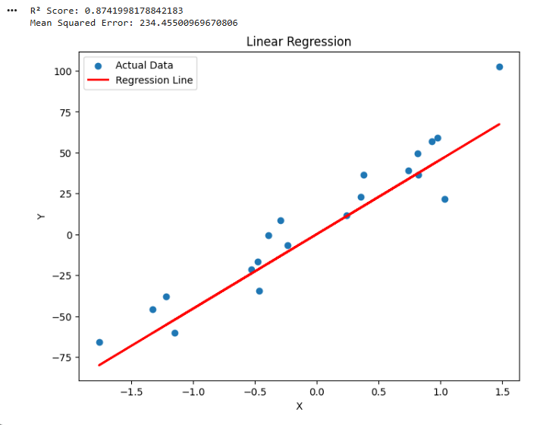

EXPERIMENT NO. 9
Comparison of Linear and Polynomial Regression using Python
AIM
To implement and compare Linear Regression and Polynomial Regression models using Python and evaluate their performance.
PROCEDURE
- Import the required Python libraries.
- Create a sample dataset containing input and output values.
- Split the dataset into training and testing data.
- Train a Linear Regression model.
- Transform the input data into polynomial features.
- Train a Polynomial Regression model.
- Predict the output using both models.
- Calculate the Mean Squared Error and R² score.
- Compare the performance of both models.
- Plot the actual data and regression curves.
INPUT
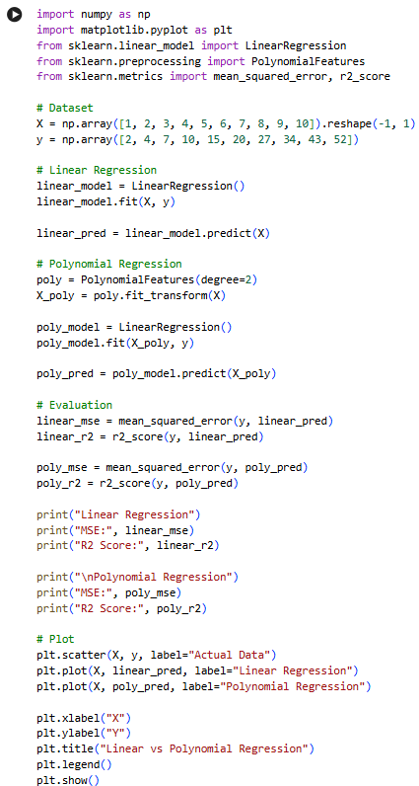
OUTPUT
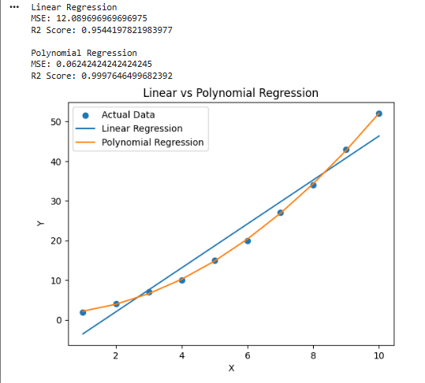
RESULT
Thus, Linear Regression and Polynomial Regression were successfully implemented and their performances were compared using MSE and R² score.

EXPERIMENT NO. 10
Implementation of Expectation-Maximization Algorithm
AIM
To implement the Expectation-Maximization (EM) algorithm in Python for clustering data into groups.
PROCEDURE
- Import the required libraries.
- Generate a sample dataset.
- Apply the Gaussian Mixture Model, which uses the EM algorithm.
- Specify the number of clusters.
- Train the model using the EM algorithm.
- Predict the cluster assigned to each data point.
- Display the clustered data graphically.
INPUT
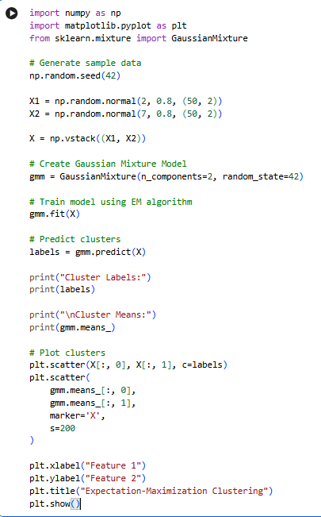
OUTPUT
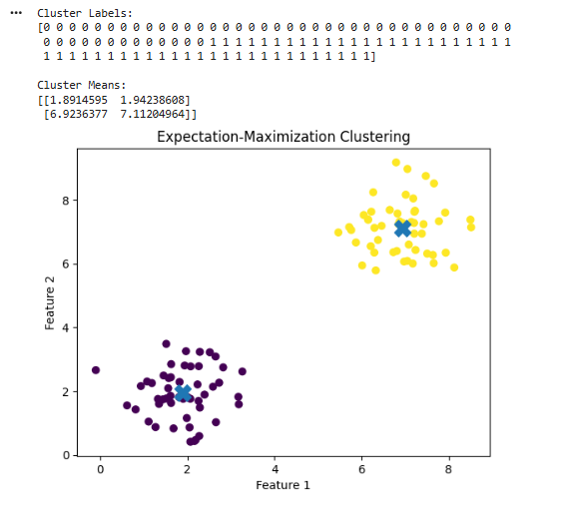
RESULT
Thus, the Expectation-Maximization algorithm was successfully implemented using a Gaussian Mixture Model and the data points were grouped into clusters.

EXPERIMENT NO. 11
Credit Score Classification
AIM
To build a machine learning model for classifying customers based on their credit-related information.
PROCEDURE
- Import the required libraries.
- Create a sample credit dataset.
- Separate the features and target variable.
- Split the dataset into training and testing sets.
- Train a classification model.
- Predict the credit category of the test data.
- Calculate the accuracy.
- Display the classification results.
INPUT
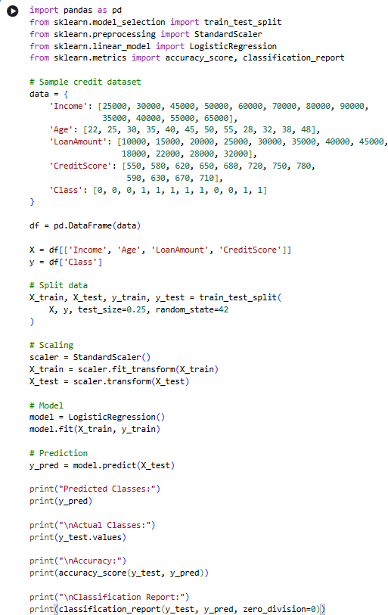
OUTPUT
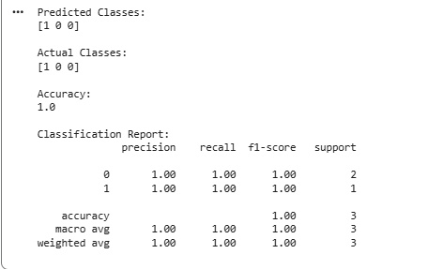
RESULT
Thus, the Credit Score Classification model was successfully implemented using Logistic Regression and its classification accuracy was obtained.

EXPERIMENT NO. 12
Iris Flower Classification using KNN
AIM
To implement the K-Nearest Neighbours algorithm for classifying Iris flowers based on their features.
PROCEDURE
- Import the Iris dataset.
- Separate the features and target values.
- Split the dataset into training and testing data.
- Create a KNN classifier.
- Train the classifier.
- Predict the flower classes for test data.
- Calculate the classification accuracy.
- Display the results.
INPUT
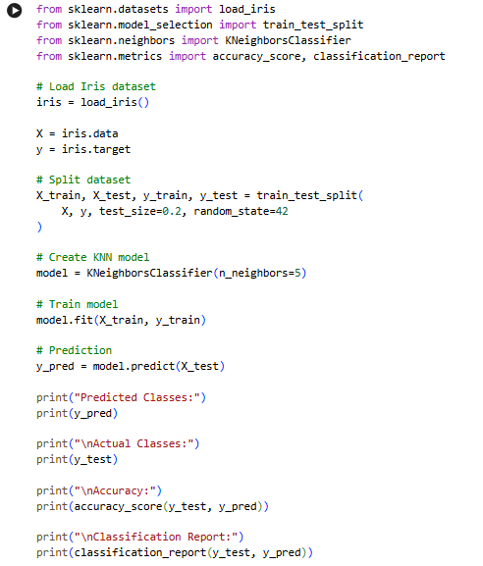
OUTPUT
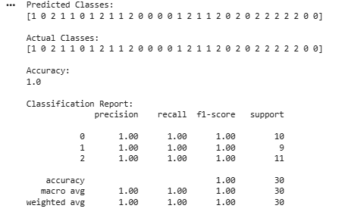
RESULT
Thus, Iris flower classification was successfully performed using the K-Nearest Neighbours algorithm

EXPERIMENT NO. 13
Car Price Prediction Model using Python
AIM
To develop a machine learning model for predicting car prices based on car features.
PROCEDURE
- Import the required libraries.
- Create a sample car dataset.
- Select the input features and target price.
- Split the dataset into training and testing data.
- Train a Linear Regression model.
- Predict car prices for the test data.
- Calculate the model performance.
- Display the predicted prices.
INPUT
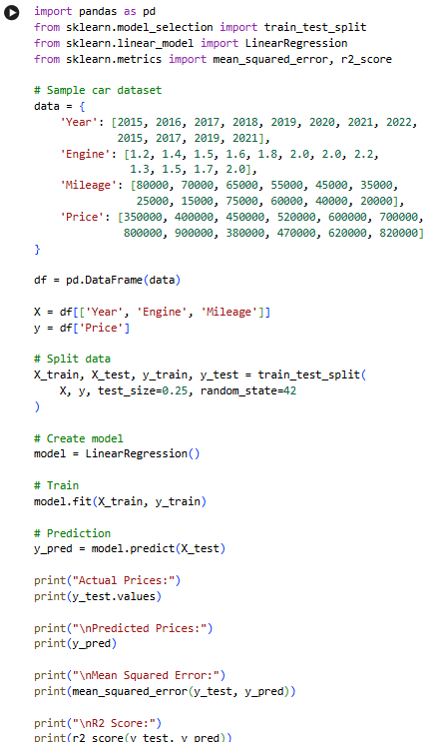
OUTPUT
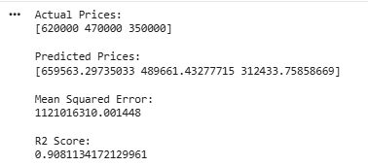
RESULT
Thus, the Car Price Prediction model was successfully implemented using Linear Regression.

EXPERIMENT NO. 14
House Price Prediction using Machine Learning
AIM
To develop a machine learning model for predicting house prices based on different house features.
PROCEDURE
- Import the required libraries.
- Create a sample house price dataset.
- Select suitable input features.
- Split the dataset into training and testing sets.
- Train a Linear Regression model.
- Predict house prices.
- Calculate MSE and R² score.
- Display the results.
INPUT
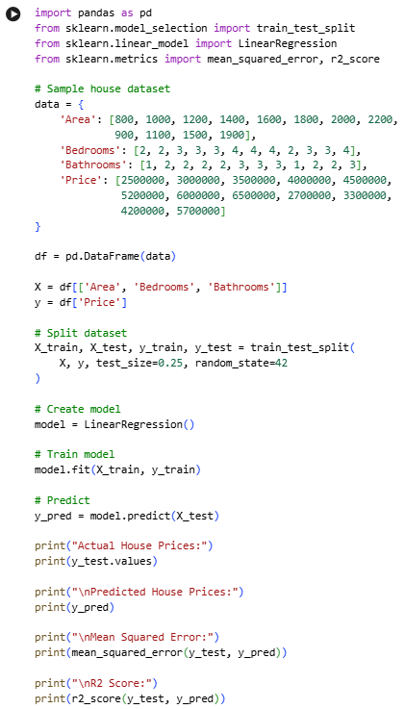
OUTPUT
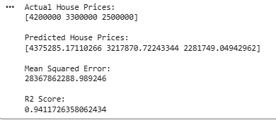
RESULT
Thus, the House Price Prediction model was successfully implemented using Linear Regression.

EXPERIMENT NO. 15
Iris Flower Classification using Naïve Bayes Classifier
AIM
To implement the Naïve Bayes classification algorithm for classifying Iris flowers.
PROCEDURE
- Load the Iris dataset.
- Separate features and target values.
- Divide the dataset into training and testing sets.
- Create a Gaussian Naïve Bayes classifier.
- Train the classifier.
- Predict the classes of test samples.
- Calculate the accuracy.
- Display the classification results.
INPUT
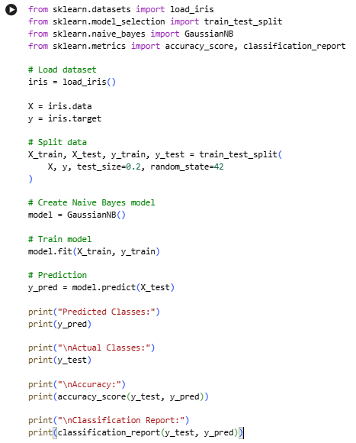
OUTPUT
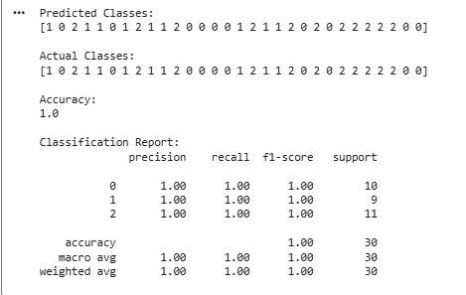
RESULT
Thus, Iris flower classification was successfully implemented using the Gaussian Naïve Bayes classifier.

EXPERIMENT NO. 16
Comparison of Different Classification Algorithms
AIM
To compare different classification algorithms and evaluate their performance using accuracy.
PROCEDURE
- Load the Iris dataset.
- Divide the dataset into training and testing sets.
- Implement Logistic Regression, KNN, Decision Tree and Naïve Bayes classifiers.
- Train each classifier using the training data.
- Predict the test data.
- Calculate the accuracy of each classifier.
- Compare the accuracy values.
INPUT
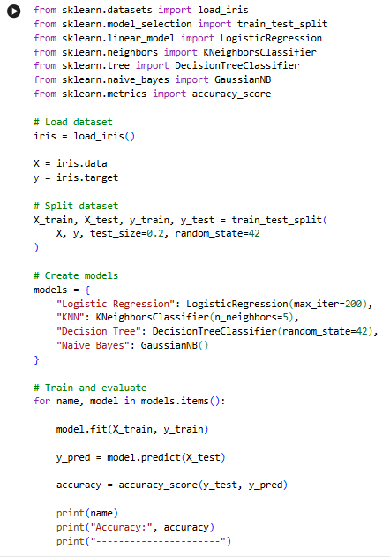
OUTPUT
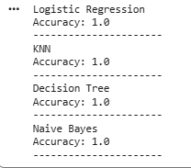
RESULT
Thus, different classification algorithms were successfully implemented and their performances were compared using classification accuracy.

EXPERIMENT NO. 17
Mobile Price Prediction using Machine Learning
AIM
To develop a machine learning model to predict the price category of mobile phones based on their features.
PROCEDURE
- Import the required libraries.
- Create a mobile phone dataset.
- Separate features and target values.
- Split the dataset into training and testing sets.
- Train a Random Forest classification model.
- Predict the mobile price category.
- Calculate the accuracy.
- Display the results.
INPUT
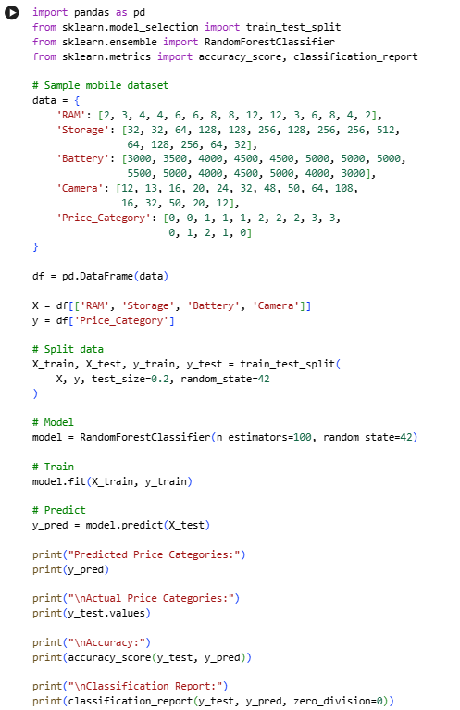
OUTPUT
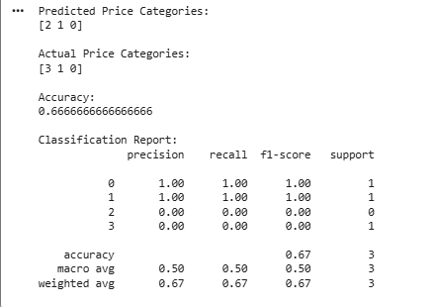
RESULT
Thus, the Mobile Price Prediction model was successfully implemented using a Random Forest classifier.

EXPERIMENT NO. 18
Perceptron Based IRIS Classification
AIM
To implement a Perceptron-based machine learning model for Iris flower classification.
PROCEDURE
- Load the Iris dataset.
- Select two classes from the Iris dataset.
- Divide the data into training and testing sets.
- Create a Perceptron classifier.
- Train the model.
- Predict the classes of test samples.
- Calculate the accuracy.
- Display the results.
INPUT
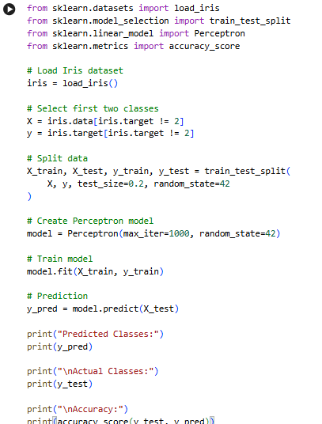
OUTPUT
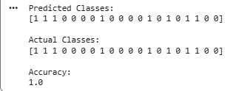
RESULT
Thus, Iris classification using the Perceptron algorithm was successfully implemented and its accuracy was calculated.

EXPERIMENT NO. 19
Naïve Bayes Classification for Bank Loan Prediction
AIM
To implement the Naïve Bayes classification algorithm for predicting whether a bank loan will be approved.
PROCEDURE
- Create a sample bank loan dataset.
- Select the relevant features.
- Divide the dataset into training and testing data.
- Create a Gaussian Naïve Bayes classifier.
- Train the classifier.
- Predict loan approval for test data.
- Calculate the accuracy.
- Display the prediction results.
INPUT
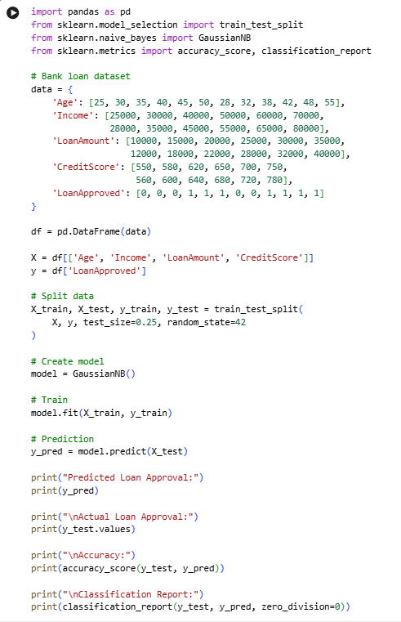
OUTPUT
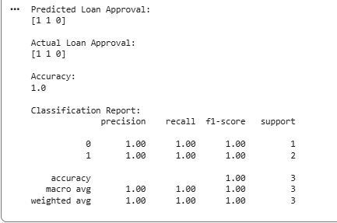
RESULT
Thus, the Naïve Bayes classification algorithm was successfully implemented for bank loan prediction.

EXPERIMENT NO. 20
Future Sales Prediction using a Suitable Machine Learning Algorithm
AIM
To develop a machine learning model for predicting future sales using historical sales data.
PROCEDURE
- Create a historical sales dataset.
- Prepare the input and target variables.
- Split the data into training and testing sets.
- Train a Linear Regression model.
- Predict future sales.
- Calculate the prediction error.
- Display the predicted sales values.
- Plot the actual and predicted sales.
INPUT
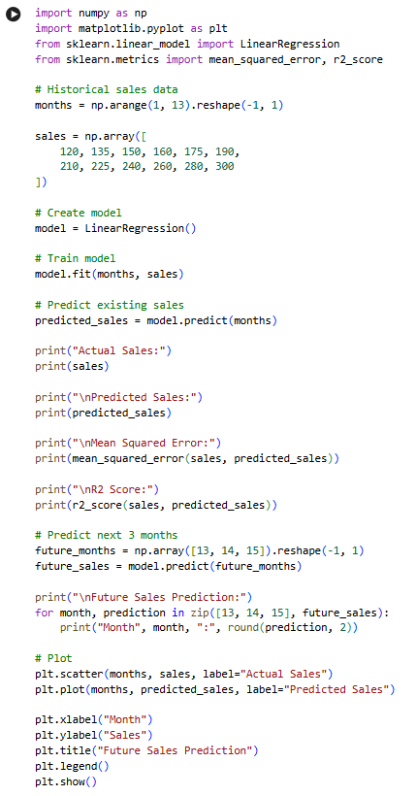
OUTPUT
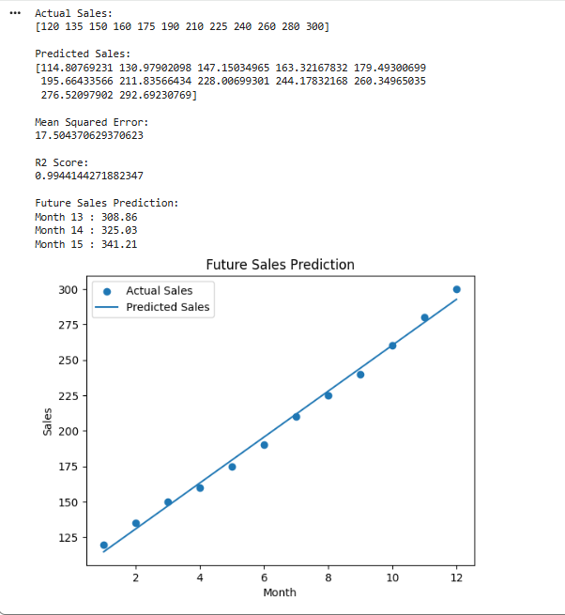
RESULT
Thus, the Future Sales Prediction model was successfully implemented using Linear Regression, and future sales values were predicted.

